**1) Use Case Diagram**

***Main Actors***

* **Admin**: Manages products, customers, sales, maintenance, inventory, reports, and users.
* **Technician**: Handles assigned maintenance requests, updates status, logs parts used.
* **Customer (via staff)**: Receives invoice, maintenance updates, and purchase history.

***Core Use Cases***

* Manage Motorcycles (Add/Edit/Delete/View/Filter)
* Record Sale & Link to Customer
* Generate/Print Invoice
* Register Maintenance Request
* Schedule & Assign Technician
* Update Maintenance Status
* Log Spare Parts Usage
* Manage Customer Profile & View History
* Track Inventory & Low Stock Alerts
* Generate Reports (Sales, Maintenance, Profit, Technician Performance)
* Login & Role-based Access
* Manage Users

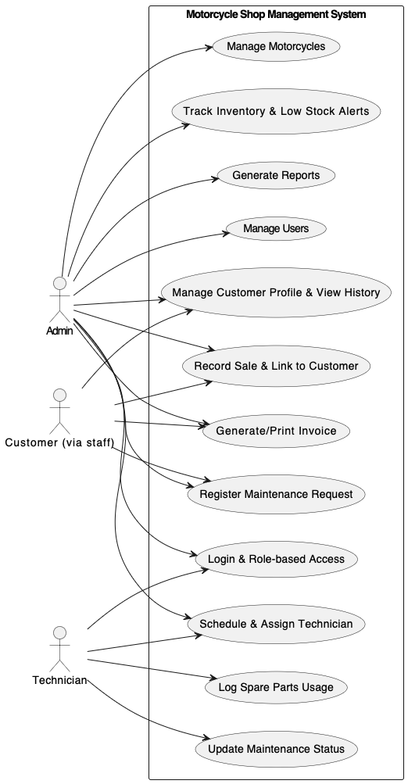

**2) Class Diagram**

***Entities & Relationships***

* **User** (id, username, passwordHash, role)
* **Customer** (id, name, phone, nationalId) → purchases → **Sale**
* **Motorcycle** (id, model, brand, price, condition, status)
* **Sale** (id, date, total, invoiceNo) → includes → **Invoice**
* **MaintenanceRequest** (id, issue, status, createdAt, scheduledAt) → linked to **Customer** and **Technician**
* **Technician** (id, name, performance metrics)
* **SparePart** (id, name, SKU(unique stock code), price) → tracked by **InventoryItem** (quantity, threshold)
* **MaintenancePartUsage** (id, qty, cost)→connects **SparePart** and **MaintenanceRequest**
* **ReportService** (methods to generate reports)

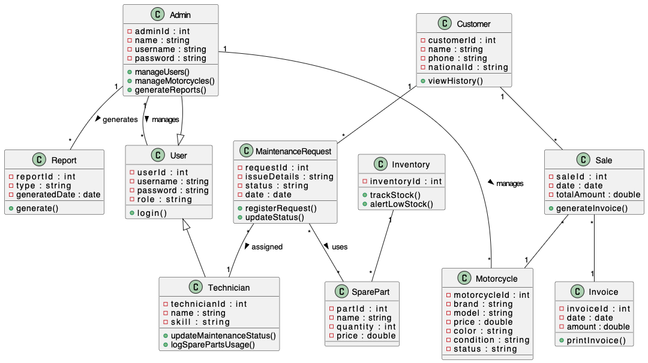

**3) Sequence Diagrams**

***A) Sale Process (Sale + Invoice + Motorcycle Status Update)***

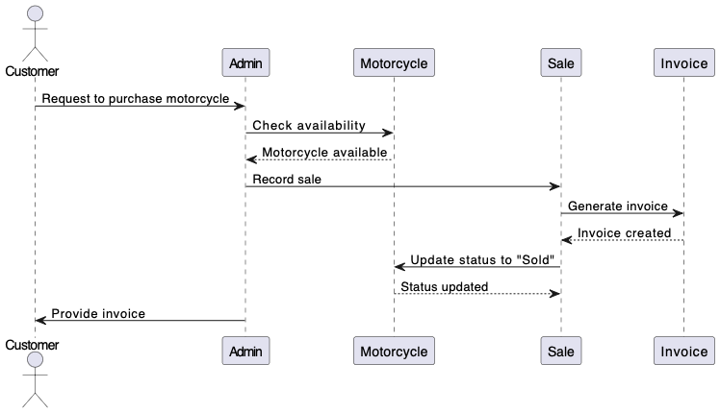

***B) Maintenance Request (Assign Technician + Parts Usage + Inventory Update)***

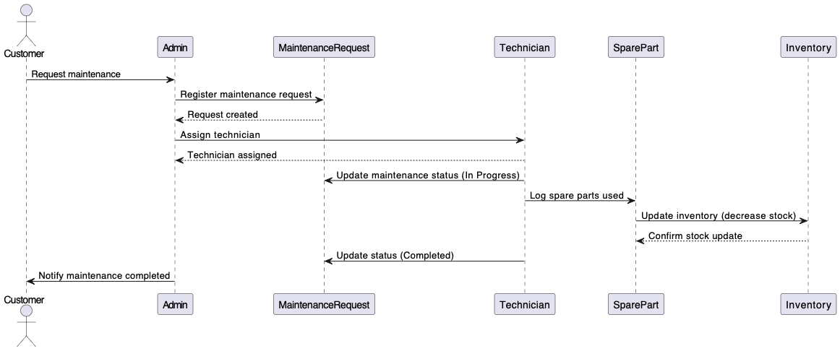

***C) Report Generation***

